Pass: MS Enterprise - Readmissions > Result Description: Test Passed for Report: MS Enterprise - Readmissions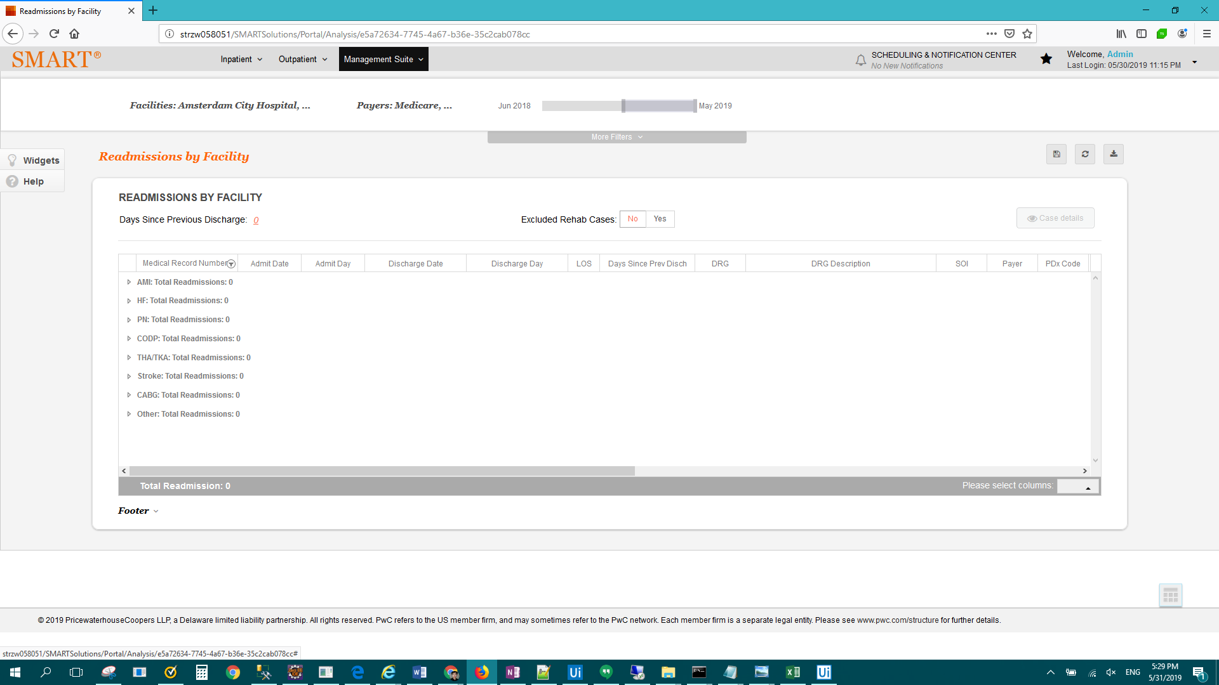

Pass: OP Standard - Medicare medical necessity flags > Result Description: Test Passed for Report: OP Standard - Medicare medical necessity flags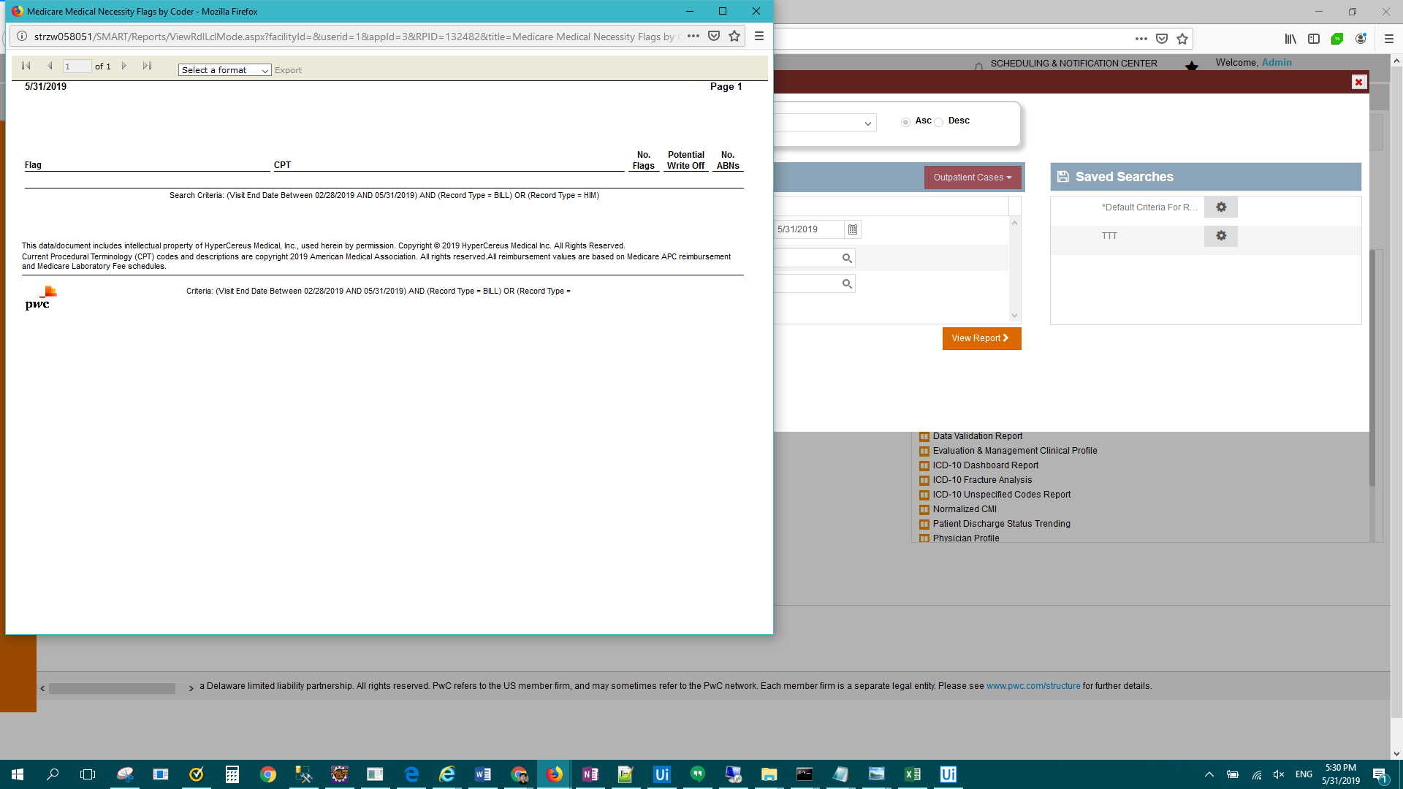

Pass: MS Enterprise - APR DRG Dashboard > Result Description: Test Passed for Report: MS Enterprise - APR DRG Dashboard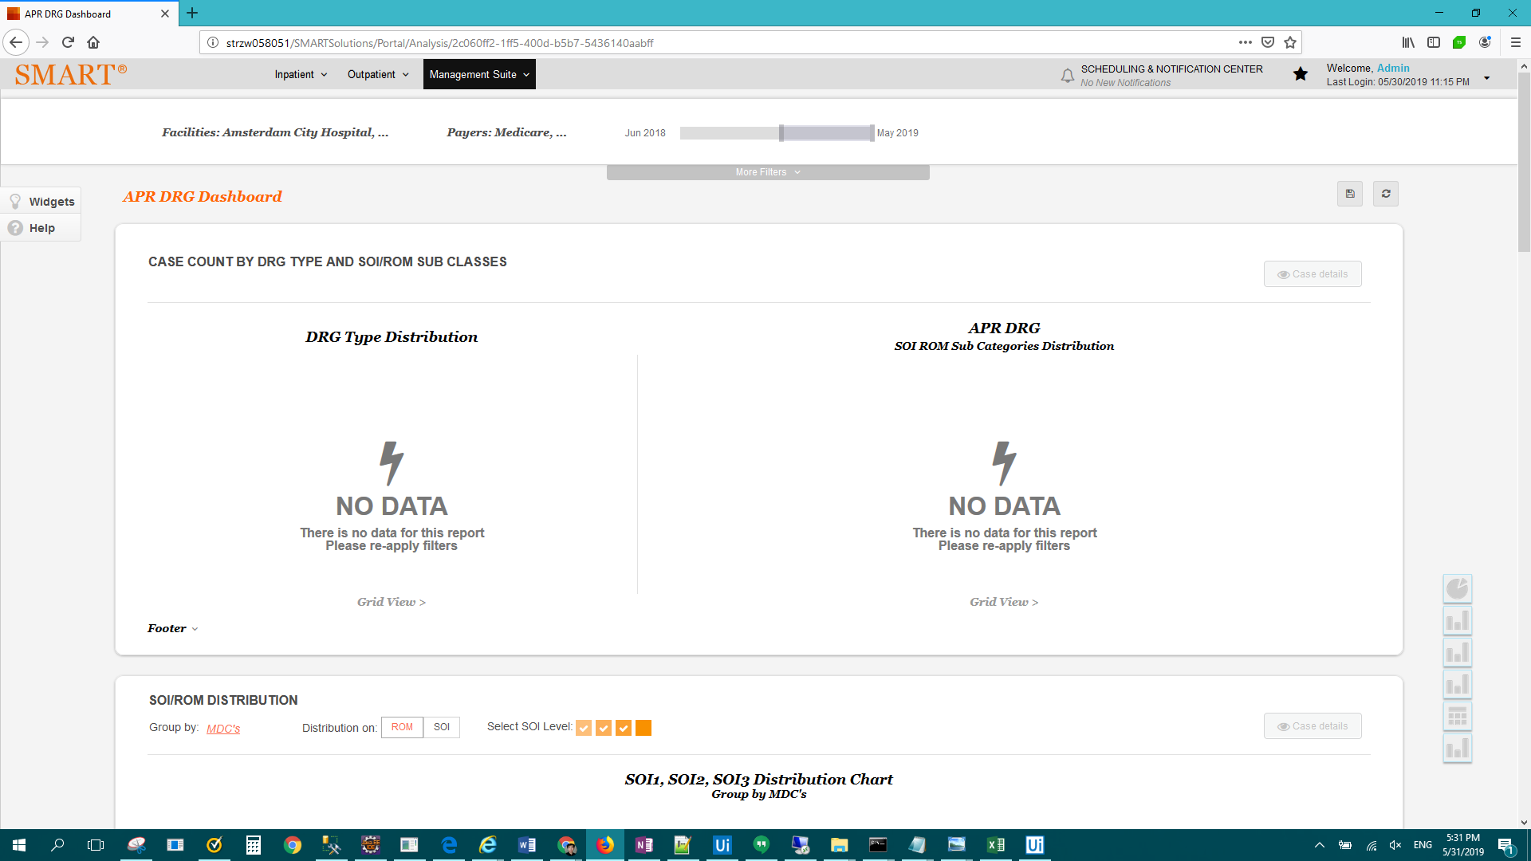

FAIL: MS Enterprise - Readmissions > Result Description: Test Failed For: MS Enterprise - Readmissions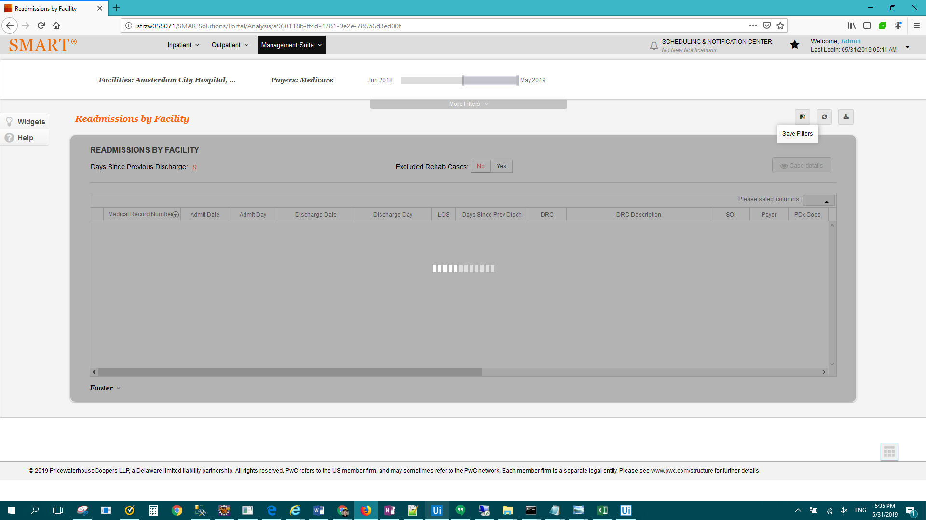

FAIL: MS Enterprise - Readmissions > Result Description: Fail: exception captured: UiPath.Core.SelectorNotFoundException: Cannot find the UI element corresponding to this selector: <html app='firefox.exe' title='Management Suite - Report Glossary' /><webctrl id='txtSearch' tag='INPUT' /> ---> System.Runtime.InteropServices.COMException: Cannot find the UI element corresponding to this selector: <html app='firefox.exe' title='Management Suite - Report Glossary' /><webctrl id='txtSearch' tag='INPUT' />

at UiPath.UiNodeClass.FindFirst(UiFindScope scope, String nodeID)

at UiPath.Core.UiElement.FindFirst(FindScope scope, Selector selector)

--- End of inner exception stack trace ---

at UiPath.Core.Activities.TaskAsyncCodeActivity`1.EndExecute(AsyncCodeActivityContext context, IAsyncResult result)

at System.Activities.AsyncCodeActivity.System.Activities.IAsyncCodeActivity.FinishExecution(AsyncCodeActivityContext context, IAsyncResult result)

at System.Activities.AsyncCodeActivity.CompleteAsyncCodeActivityData.CompleteAsyncCodeActivityWorkItem.Execute(ActivityExecutor executor, BookmarkManager bookmarkManager)

FAIL: MS Enterprise - APR DRG Dashboard > Result Description: Test Passed for Report: MS Enterprise - APR DRG Dashboard